National University of Computer and Emerging Sciences



Laboratory Manuals

for

Database Systems Lab
(CL -2005)

Course Instructor | Ms. Aleena Ahmad
Lab Instructor | Muhammad Kamran
Lab TA | Abdullah Naeem
Section | BCS-4F
Semester | Spring 2025

Department of Computer Science
FAST-NU, Lahore, Pakistan
Lab Manual 02

SQL
SQL tutorial gives unique learning on Structured Query Language and it helps to make practice on SQL commands which provides immediate results. SQL is a language of database, it includes database creation, deletion, fetching rows and modifying rows etc. SQL is an ANSI (American National Standards Institute) standard, but there are many different versions of the SQL language.
Why SQL?
- Allows users to access data in relational database management systems.
- Allows users to describe the data.
- Allows users to define the data in the database and manipulate that data.
- Allows embedding within other languages using SQL modules, libraries & pre-compilers.
- Allows users to create and drop databases and tables.
- Allows users to create views, stored procedure, functions in a database.
- Allows users to set permissions on tables, procedures and views
SQL Process
When you are executing an SQL command for any RDBMS, the system determines the best way to carry out your request and SQL engine figures out how to interpret the task.
There are various components included in the process. These components are Query Dispatcher, Optimization Engines, Classic Query Engine and SQL Query Engine, etc. Classic query engine handles all non-SQL queries, but SQL query engine won't handle logical files.
Following is a simple diagram showing SQL Architecture:
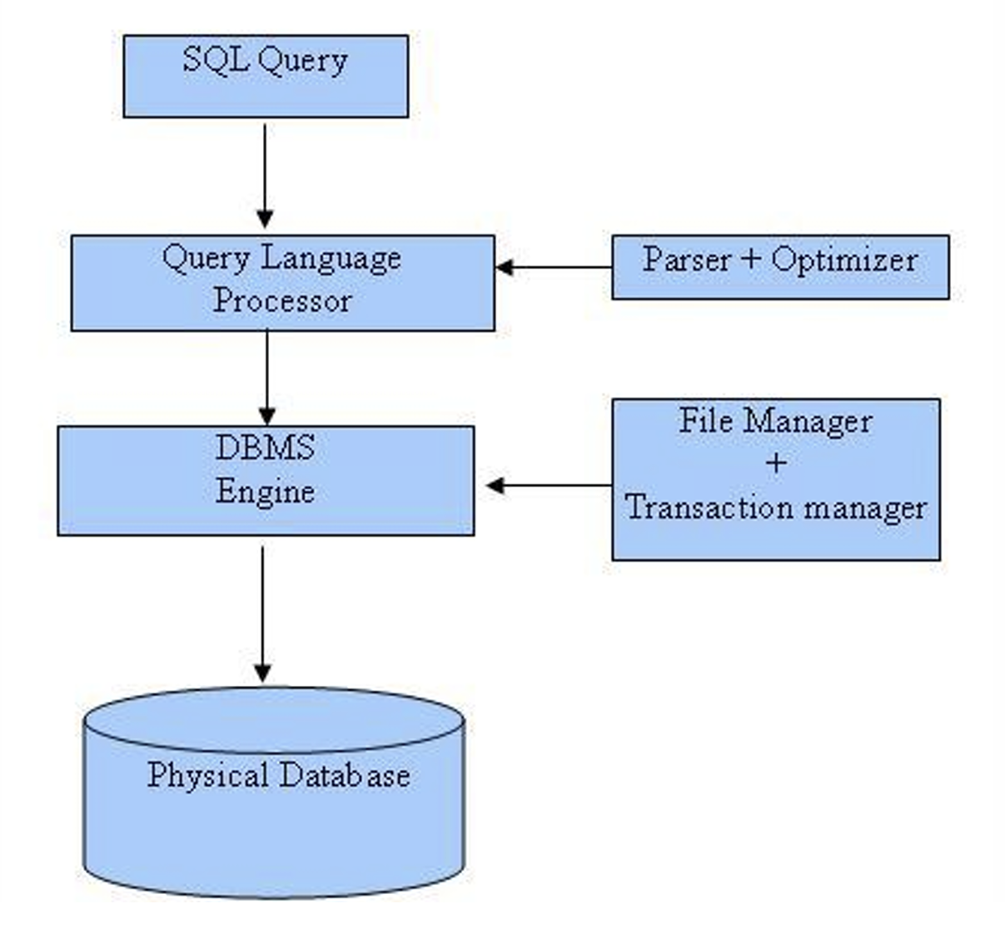
SQL Commands
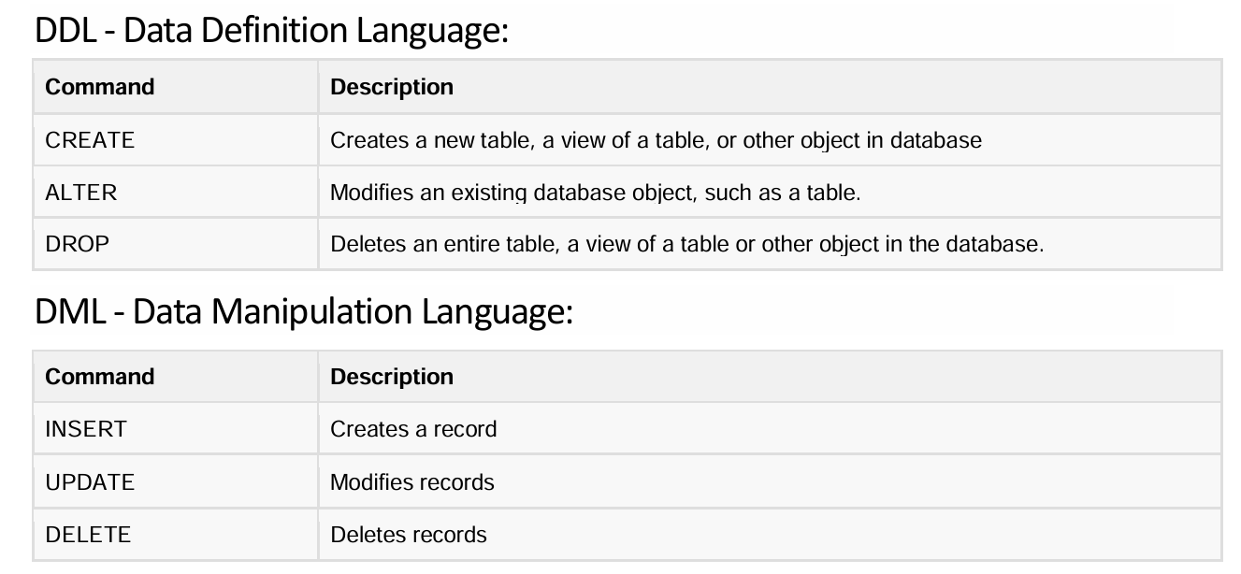

Overview of DDL

Create a Database:
In order add data in our database, we first need to create our database. The syntax for creating database is as follows:
Create database databasename;

Example:
Create database myDB;

Use a database:
To tell the DBMS about the database in which we want to create database tables or add data, we need to use the following syntax after creating our database:
Use databasename;

Delete a Database:
We can delete a database by using the following syntax:
Drop database databasename

Example:
Drop database myDB;

The above statement will delete all tables of myDB and their data.

Create a Table in Database:
The CREATE TABLE statement is used to create a new table in a database.
Create Table table_name (
column1 datatype,
column2 datatype,
column3 datatype,
....
);

Example:
Create Table Student
(
rollNumber int,
name nvarchar(100),
cnic nvarchar(100),
cgpa float
)

To learn about datatypes in SQL Server visit the following link, and see datatypes under SQL SERVER Data types:
https://www.w3schools.com/sql/sql_datatypes.asp

- Drop a Table:
A table can be drop using the following syntax: (Dropping a table will delete the table data as well as table definition)
Drop Table tableName

Example:
Drop Table Student

Truncate a Table:
A table can be truncated using the following syntax: (Truncating a table will only delete the data in the table and not table definition)
Truncate Table tableName

Example:
Truncate Table Student

SQL Constraints
NOT NULL - Ensures that a column cannot have a NULL value
UNIQUE - Ensures that all values in a column are different
PRIMARY KEY - A combination of a NOT NULL and UNIQUE. Uniquely identifies each row in a table
FOREIGN KEY - Uniquely identifies a row/record in another table
CHECK - Ensures that all values in a column satisfies a specific condition
DEFAULT - Sets a default value for a column when no value is specified
Constraints can be specified when the table is created with the CREATE TABLE statement, or after the table is created with the ALTER TABLE statement.

NOT NULL Constraint
By default, a column can hold NULL values. The NOT NULL constraint enforces a column to NOT accept NULL values. This enforces a field to always contain a value, which means that you cannot insert a new record, or update a record without adding a value to this field.
Add NOT NULL Constraint Using Create Table:
Create Table Student
(
rollNumber int NOT NULL,
name nvarchar(50) NOT NULL,
cgpa float NULL
)

Add NOT NULL Constraint Using ALTER Table:
Alter Table Student Alter column rollNumber int NOT NULL

UNIQUE Constraint
The UNIQUE constraint ensures that all values in a column are different.

Add Unique Constraint Using Create Table
Create Table Student
(
rollNumber int NOT NULL,
name nvarchar(50) NOT NULL,
cnic nvarchar(50) NOT NULL unique,
cgpa float NULL
)

Unique constraint can also be defined as follows:

Create Table Student
(
rollNumber int NOT NULL,
name nvarchar(50) NOT NULL,
cnic nvarchar(50) NOT NULL,
cgpa float NULL
unique (cnic)

Add Unique Constraint Using Alter Table
Alter Table Student add constraint UNIQUE_CONSTRAINT_STUDENT_CNIC Unique (cnic)

Unique Constraint on a Combination of Columns
Unique constraint can also be applied on a combination of columns:

Create Table Student
(
rollNumber int NOT NULL,
name nvarchar(50) NOT NULL,
cnic nvarchar(50) NOT NULL,
cgpa float NULL,
unique (cnic, name)
)

(OR)

Alter Table Student add constraint UNIQUE_CONSTRAINT_STD_CNIC_NAME Unique (cnic, name)

Primary Key Constraint
The primary key constraint uniquely identifies each row in a table. Primary keys must contain UNIQUE values, and cannot contain NULL values. A table can have only one primary key, which may consist of single or multiple columns.

Add Primary Key Constraint Using Create Table
Create Table Student
(
rollNumber int primary key,
name nvarchar(50) NOT NULL,
cnic nvarchar(50) NOT NULL,
cgpa float NULL
)

(OR)

Create Table Student
(
rollNumber int,
name nvarchar(50) NOT NULL,
cnic nvarchar(50) NOT NULL,
cgpa float NULL
primary key (rollNumber)
)

Add Primary Key Constraint Using Alter Table
To add primary key using alter table statement, the column must have not null constraint, otherwise the not null constraint must first be defined.

Alter Table Student alter column rollNumber int NOT NULL
Alter Table Student add constraint PK_STUDENT primary key (rollNumber)

Composite Primary Key
A primary key involving more than one column is called composite primary key.

Add composite Primary Key Using Alter Table
Create Table Student
(
rollNumber int,
name nvarchar(50),
cnic nvarchar(50),
cgpa float,

primary key (rollNumber, cnic)
)

Add Composite Primary Key Using Alter Table
Alter Table Student add constraint PK_STUDENT primary key (rollNumber, cnic)

Foreign Key Constraint
A foreign key is a column (or a collection of columns) in one table that refers to the primary key in another table. The value of the foreign key comes from the table in which it is the primary key.

Add Foreign Key Constraint Using Create Table

CREATE TABLE Student (
rollNumber int PRIMARY KEY,
deptId int FOREIGN KEY REFERENCES Department(departmentId)
);

(OR)

CREATE TABLE Student(
rollNumber int,
deptId int,
PRIMARY KEY (rollNumber),
FOREIGN KEY (deptId) REFERENCES Department(departmentId)
);

Add Foreign Key Constraint Using Alter Table:
Alter Table Student add constraint FK_STUDENT foreign key (deptId) references Department (departmentId)

Cascade/No Action/Set NULL:
We can define some actions for a foreign key value whenever there is a change (update or delete) in the primary key value.

If we want to update the foreign key value when the corresponding primary key value is updated, and delete the foreign key value whenever the corresponding primary key value is deleted; we use cascade option.

If we want to set the foreign key value to null whenever the corresponding primary key value is updated or deleted, then we use set NULL option.

If we want to force the foreign key to remain unchanged, we will use No Action option. If No Action is specified, then the primary key value will not be allowed to delete or update in the referenced table if there is a corresponding value of foreign key in the referencing table.

Example:
Create Table Student
(
rollNumber int primary key,
deptId int,
name nvarchar(50) NOT NULL,
cnic nvarchar(50) NOT NULL,
)

Create Table Department
(
departmentId int primary key,
departmentName nvarchar(50)
)

alter table Student add constraint FK_STUDENT foreign key (deptId) references Department (departmentId) on delete No Action on update Cascade

Composite Foreign key:
A primary key which is composite in the referenced table will form a composite foreign key in the referencing table (all attributes of the composite primary key must be part of the foreign key in such a case).

Check Constraint
The check constraint is used to limit the value range that can be placed in a column.

Add Check Constraint Using Create Table
Create Table Student
(
rollNumber int,
name nvarchar(50) NOT NULL,
cnic nvarchar(50) NOT NULL,
cgpa float NULL check (cgpa>=0 AND cgpa<=4),
)

(OR)
Create Table Student
(
rollNumber int,
name nvarchar(50) NOT NULL,
cnic nvarchar(50) NOT NULL,
cgpa float NULL,
check (cgpa>=0 AND cgpa<=4)
)

Add Check Constraint Using Alter Table
alter table Student add Constraint STUDENT_CHECK_CGPA check (cgpa>=0 AND cgpa<=4)

Check Constraint can be applied to relate the value of a column with another column:
Create Table StudentMarks
(
rollNumber int,
obtainedMarks float,
maximumMarks float,
check (obtainedMarks >=0 AND obtainedMarks<= maximumMarks)
)

Default Constraint
Default constraint is used to assign a default value to a column when no value is specified by the user during data insertion.

Add Default Constraint Using Create Table
Create Table Student
(
rollNumber int,
name nvarchar(50) NOT NULL,
cnic nvarchar(50) NOT NULL,
cgpa float default 0,
check (cgpa>=0 AND cgpa<=4)
)

Add Default Constraint Using Create Table
alter table Student add constraint DEFAULT_SUDENT_CGPA default 0 for CGPA

Drop a Constraint
alter table Student drop constraint DEFAULT_SUDENT_CGPA

Add a New Column
Create Table Student
(
rollNumber int,
name nvarchar(50) NOT NULL,
cnic nvarchar(50) NOT NULL
)

alter table Student add cgpa float NOT NULL

Drop a Column
alter table Student drop column cnic

Modify a Column
Create Table Student
(
rollNumber int,
name nvarchar(50) NOT NULL,
cnic nvarchar(50) NOT NULL,
)
alter table Student alter column rollNumber varchar(100) NOT NULL

Overview of DML

Step 1: Insert rows into table
Syntax
-- let there be N columns in a table
INSERT INTO <tableName>
values
(Column1Value,Column2Value, Column3Value,….,ColumnNValue), --row 1
(Column1Value,Column2Value, Column3Value,….,ColumnNValue), --row2
(Column1Value,Column2Value, Column3Value,….,ColumnNValue) –row 3

Or
INSERT INTO <tableName> (ColumnX,ColumnY) -- List of Columns
values
(ColumnXValue,ColumnYValue), --Row 1 list of Corrrespong column values
(ColumnXValue,ColumnYValue), --Row 2
(ColumnXValue,ColumnYValue) –Row 3

Try the following
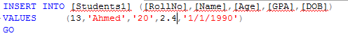
Try the following
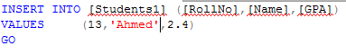

Step 2: To see the data from you table use the following table
Select * from tableName

Try the following and see the results
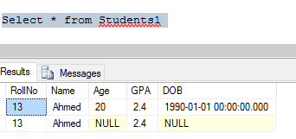

Step 3: Delete rows from the table
Delete from <tableName>
Where <conditions>

Try the following and see the message and data in table using select query

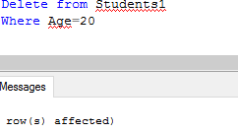

Step 4: Delete all the data from the table
Delete from <tableName> --as there is no where condition all rows will be deleted
Or
Truncate table <tableName>

Try these two commands after adding some rows to the table and see the results.

Step 5: Updating the rows
Update tableName
set ColumnA=<NewValue>,
ColumnB=<NewValue>,
where <Conditions>

See the data in table before and after trying the following query
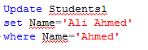

In Lab Exercises
Create a database and schema that contain the following tables.

Student:
RollNum | Name | Gender | Phone
L230844 | Ahmed Muaz | Male | 0333-3333333
L124147 | Kalsoom | Female | 0333-3456789
L230654 | Sabih Ud Din | Male | 0345-3243567

Attendance:
RollNum | Date | Status | ClassVenue
L230844 | 2-22-2016 | P | 2
L124147 | 2-23-2016 | A | 1
L230654 | 3-4-2016 | P | 2

ClassVenue:
ID | Building | RoomNum | TeacherId
1 | CS | 2 | 1
2 | Civil | 7 | 2

Teacher:
id | Name | Designation | Department
1 | Dr. Zeeshan Ali Rana | Assistant Prof. | Software Engineering
2 | Mr. Zeeshan Nazar | Lecturer | Data Science
3 | Dr. Kashif zafar | Professor | Computer Science

Q1: Create all the tables and add all the rows. (format for date mm-dd-yy e.g, ‘02-22-2017’)

Q2: Identify one PK from each table and add the constraint

Q3: Identify all the FK constraints, and add those constraints, such that:
- If the Student table or ClassVenue Table or Teacher table is updated the referencing columns should also reflect the changes.
- Student should not be deleted if the details of his Attendance are present.

Q4: Alter table Student by adding new column “warning count”.

Q5: Perform the following DML actions on your database, identify whether these operations are valid or not, also state how can we make the invalid queries valid? (Your answers should be written in comments along with your queries).

- Add new row into Student table, values <L162334, Fozan Shahid, Male, 3.2 >

- Add new row into ClassVenue table, values <3, CS, 5, Ali>

- Update Teacher table Change “Kashif zafar” name to “Dr. Kashif Zafar”.

- Delete Student with rollnum “L162334”

- Delete Student with rollnum “L164123”

- Delete Attendance with rollnum “L164124”, if his status is absent.

Q6:
- Alter table and Add CNIC in student table.
- Alter table and drop phone column from student table.
- Alter table and add the unique constraint on teacher name.
- Alter Student table and allow values only Female and Male for gender.
- Alter Attendance table and allow A and P as status values only.

Extra Exercises & Project Practice
- Create the following tables using SQL Queries
1) Table Name: salesman

salesman_id name city commission
--------------- ------ ----- ---------------
5001 James Hoog New York 0.15
5002 Nail Knite Paris 0.13
5005 Pit Alex London 0.11
5006 Mc Lyon Paris 0.14
5007 Paul Adam San Jose 0.13
5003 Lauson Hen San Jose 0.12

2) Table Name: orders
ord_no purch_amt ord_date customer_id salesman_id
---------- ---------- ---------- ----------- -----------
70001 150.5 2012-10-05 3005 5002
70009 270.65 2011-09-10 3001 5005
70002 65.26 2014-10-05 3002 5001
70004 110.5 2011-08-17 3009 5003
70007 948.5 2012-09-10 3005 5002
70005 2400.6 2010-07-27 3007 5001
70008 5760 2013-09-10 3002 5001
70010 1983.43 2010-10-10 3004 5006
70003 2480.4 2013-10-10 3009 5003
70012 250.45 2010-06-27 3008 5002
70011 75.29 2014-08-17 3003 5007
70013 3045.6 2010-04-25 3002 5001

3) Table Name: customers
customer_id cust_name city grade salesman_id
--------------- ------------- ----- ------- ------------
3002 Nick Rimando New York 100 5001
3007 John Brad Davis New York 200 5001
3005 Graham Zusi California 200 5002
3008 Julian Green London 300 5002
3004 Fabian Johnson Paris 300 5006
3009 Geoff Cameron Berlin 100 5003
3003 Jozy Altidor Moscow 200 5007
3001 John Brad Guzan London Null 5005

- Connect to SQL Server using connection string from NodeJS
- Write requests in NodeJS to insert rows in SQL Tables
For Example
Sending POST request to http://localhost:5000/create_customer with a body having key value pairs should create a new row in SQL Table

Submission Guidelines
- submit following files strictly following the naming convention
  - l231234.sql

